Лабораторна робота№14

Multithreading. Ефективність використання
Мета:Вимірювання часу паралельних та послідовних обчислень.Демонстрація ефективності паралельної обробки.
ВИМОГИ
Забезпечити вимірювання часу паралельної обробки елементів контейнера за допомогою розроблених раніше методів.
- Додати до алгоритмів штучну затримку виконання для кожної ітерації циклів поелементної обробки контейнерів, щоб загальний час обробки був декілька секунд.
- Реалізувати послідовну обробку контейнера за допомогою методів, що використовувались для паралельної обробки та забезпечити вимірювання часу їх роботи.
- Порівняти час паралельної і послідовної обробки та зробити висновки про ефективність розпаралелювання:
результати вимірювання часу звести в таблицю;
обчислити та продемонструвати у скільки разів паралельне виконання швидше послідовного.
ВИМОГИ
1.1 Розробник

Єрмаков Дмитро Сергійович
Група КИТ-119в
Варіант 10

Текст програми

import java.io.Serializable;
public class Memory<T> implements Serializable {
public T obj;
public Memory<T> next;
public Memory<T> prev;
public Memory() {
super();
// TODO Auto-generated constructor stub
}
public Memory(T obj, Memory<T> next, Memory<T> prev) {
super();
this.obj = obj;
this.next = next;
this.prev = prev;
}
}

public class My_List<T> implements Serializable, Iterable<T>{
private static final long serialVersionUID = 1L;
private Memory<T> start;
private Memory<T> tail;
private int size;
public int get_size()
{
return size;
}
public void add_elements(T obj)
{
size ++;
Memory<T> temp = tail.prev;
temp.next = new Memory<T>();
tail.prev = temp.next;
temp.next.obj = obj;
temp.next.next = tail;
temp.next.prev = temp;
}
public void delete(int number)
{
if(number>=size)
return;
Memory<T> temp = start.next;
Memory<T> temp2 = null;
for(int i = 0; i < number;i++) {
temp = temp.next;
}
temp2 = temp.prev;
temp2.next = temp.next;
temp.next.prev = temp2;
size--;
}
public void cls()
{
tail.prev = start;
start.next = tail;
size = 0;
}
public String toString() {
String str = new String();
for(T value : this) {
str += value + "\n";
}
return str;
}
public T[] toArray(T[] arr)
{
int i=0;
for (T t : this) {
arr[i++] = t;
}
return arr;
}
public T get(int number) {
if(number>=size && number<0)
return null;
Memory<T> temp = start.next;
for(int i = 0; i < number;i++) {
temp = temp.next;
}
return temp.obj;
}
public boolean null_or_not() {
if(size!=0)
{
return true;
}
else
{
return false;
}
}
public My_List() {
super();
this.size = 0;
this.start = new Memory<T>(null,tail,null);
this.tail = new Memory<T>(null,null,start);
}
public My_List(Memory<T> start,Memory<T> tail, int size) {
super();
this.start = start;
this.tail = tail;
this.size = size;
}
@Override
public Iterator<T> iterator() {
return new Iterator<T>() {
int itr = 0;
@Override
public boolean hasNext() {
return itr < size;
}
@Override
public T next() {
return get(itr++);
}
@Override
public void remove() {
delete(itr-1);
}
};
}
public void swap(int i1, int i2) {
if (i1 >= size && i2 >= size && i1 == i2)
return;
Memory<T> temp1 = start.next;
Memory<T> temp2 = start.next;
for (int i = 0; i < i1; i++) {
temp1 = temp1.next;
}
for (int i = 0; i < i2; i++) {
temp2 = temp2.next;
}
T temp = temp1.obj;
temp1.obj = temp2.obj;
temp2.obj = temp;
}
}

import java.util.LinkedHashMap;
import java.util.Set;
public class HumanResourcesDepartment {
private LinkedHashMap<String, String> passport_data;
private String education;
private int salary;
private LinkedHashMap<String, String> career;
private LinkedHashMap<String, Integer> characteristic;
public LinkedHashMap<String, String> getPassport_data() {
return passport_data;
}
public void setPassport_data(LinkedHashMap<String, String> passport_data) {
this.passport_data = passport_data;
}
public String getEducation() {
return education;
}
public void setEducation(String education) {
this.education = education;
}
public int getSalary() {
return salary;
}
public void setSalary(int salary) {
this.salary = salary;
}
public LinkedHashMap<String, String> getCareer() {
return career;
}
public void setCareer(LinkedHashMap<String, String> career) {
this.career = career;
}
public LinkedHashMap<String, Integer> getCharacteristic() {
return characteristic;
}
public void setCharacteristic(LinkedHashMap<String, Integer> characteristic) {
this.characteristic = characteristic;
}
public String getName()
{
return new String(passport_data.get("Name "));
}
public String getSurname()
{
return new String(passport_data.get("Surname "));
}
public String getFamily()
{
return new String(passport_data.get("Family "));
}
public String getPassport_ID()
{
return new String(passport_data.get("Passport ID "));
}
public String getPassport_series()
{
return new String(passport_data.get("Passport series "));
}
public String getDateOfAppointment()
{
return new String(career.get("Date of appointment "));
}
public String getPosition()
{
return new String(career.get("Position "));
}
public String getDepartment()
{
return new String(career.get("Department "));
}
public void setDateOfAppointment(String el)
{
career.put("Date of appointment ", el);
}
public void setPosition(String el)
{
career.put("Position ", el);
}
public void setDepartment(String el)
{
career.put("Department ",el);
}
public String getAverage_ratting()
{
float avg=0f;
Set set = characteristic.keySet();
for (Object object : set) {
avg += characteristic.get(object);
}
float res = avg/characteristic.size();
return Float.toString(res);
}
public HumanResourcesDepartment() {
super();
// TODO Auto-generated constructor stub
}
public HumanResourcesDepartment(LinkedHashMap<String, String> passport_data, String education, int salary,
LinkedHashMap<String, String> career, LinkedHashMap<String, Integer> characteristic) {
super();
this.passport_data = passport_data;
this.education = education;
this.salary = salary;
this.career = career;
this.characteristic = characteristic;
}
public String passport_dataTo_string() {
String string ="";
Set set = passport_data.entrySet();
for (Object el: set) {
string+=el.toString();
string+="\n";
}
return string;
}
public String careerTo_string() {
String string ="";
Set set = career.entrySet();
for (Object el: set) {
string+=el.toString();
string+="\n";
}
return string;
}
public String characteristicTo_string() {
String string ="";
Set set = characteristic.entrySet();
for (Object el: set) {
string+=el.toString();
string+="\n";
}
return string;
}
public void Show()
{
System.out.println("���������� ������ - \n"+ passport_dataTo_string() +"\r" +
"����������� - "+ education + "\r\n" +
"����� - " + salary +"\r\n"+
"������� " + careerTo_string() +"\r"+
"�������������� "+ characteristicTo_string() + "\r\n");
}
public String toString()
{
return "���������� ������ - \n"+ passport_dataTo_string() +"\r" +
"����������� - "+ education + "\r\n" +
"����� - " + salary +"\r\n"+
"������� " + careerTo_string() +"\r"+
"�������������� "+ characteristicTo_string() + "\r\n";
}
}

import java.util.Comparator;
public class Helper {
static <T extends HumanResourcesDepartment> void sort(My_List<T> collection, ESort choose) {
boolean przEnd = true;
while (przEnd) {
przEnd = false;
for (int i = 0; i < collection.get_size() - 1; i++) {
switch (choose) {
case PASSPORT_ID:{
if (collection.get(i).getPassport_ID().compareTo(collection.get(i + 1).getPassport_ID()) > 0) {
collection.swap(i, i + 1);
przEnd = true;
}
break;}
case PASSPORT_SERIES:{
if (collection.get(i).getPassport_series().compareTo(collection.get(i + 1).getPassport_series()) > 0) {
collection.swap(i, i + 1);
przEnd = true;
}
break;}
case SALARY:{
Comparator<HumanResourcesDepartment> comparator_salary = (a,b) -> (a.getSalary() < b.getSalary()) ? -1 : ((a.getSalary() == b.getSalary()) ? 0 : 1);
HumanResourcesDepartment el1 = collection.get(i);
HumanResourcesDepartment el2 = collection.get(i+1);
if(el1.equals(el2))
{
collection.swap(i, i + 1);
przEnd = true;
}
break;
}
case RATING:{
if (collection.get(i).getAverage_ratting().compareTo(collection.get(i + 1).getAverage_ratting()) > 0) {
collection.swap(i, i + 1);
przEnd = true;
}
break; }
default:
break;
}
}
}
}
public Helper() {
// TODO Auto-generated constructor stub
}
enum ESort {
PASSPORT_ID,
PASSPORT_SERIES,
SALARY,
RATING
}
}

import java.io.BufferedReader;
import java.io.FileInputStream;
import java.io.FileOutputStream;
import java.io.IOException;
import java.io.InputStreamReader;
import java.io.ObjectInputStream;
import java.io.ObjectOutputStream;
import java.util.LinkedHashMap;
import java.util.Scanner;
import java.util.regex.Matcher;
import java.util.regex.Pattern;
public class Main {
private static Pattern name_p = Pattern.compile("[�-��-�a-zA-Z/-/ ]*");
private static Pattern surname_p = Pattern.compile("[�-��-�a-zA-Z/-/ ]*");
private static Pattern family_p = Pattern.compile("[�-��-�a-zA-Z/-/ ]*");
private static Pattern salary_p = Pattern.compile("[0-9]*");
private static Pattern pasport_id_p = Pattern.compile("[0-9]{8}");
private static Pattern pasport_ser_p = Pattern.compile("[�-��-�a-zA-Z/-/ 0-9]*");
private static Pattern date_p = Pattern.compile("[0-9/.]*");
private static Pattern position_p = Pattern.compile("[�-��-�a-zA-Z/-/ ]*");
private static Pattern departament_p = Pattern.compile("[�-��-�a-zA-Z/-/ ]*");
private static Pattern property_p = Pattern.compile("[�-��-�a-zA-Z/-/ ]*");
private static Pattern rating_p = Pattern.compile("[0-9]*");
private static Pattern education_p = Pattern.compile("[�-��-�a-zA-Z/-/ ]*");
private static Pattern name_x_p = Pattern.compile("��.*�.*");
private static Pattern pasport_ser_x_p = Pattern.compile("0�");
private static Pattern pasport_id_x_p = Pattern.compile("[0-9]*");
private static Matcher res;
public static void main(String[] args) throws IOException, ClassNotFoundException {
String status = "";
if(args.length>0)
{
if(args[0].equals("-auto")||args[0].equals("-a"))
status = "auto";
if (args[0].equals("-dialog")||args[0].equals("-d"))
status = "dialog";
}
else
{
System.out.println("�� �� ������ ����� ������, ����� ���������!");
return;
}
My_List<HumanResourcesDepartment> obj = new My_List<HumanResourcesDepartment>();
if(status=="auto")
{
int i = 0;
LinkedHashMap<String, String> passport_data = new LinkedHashMap<String, String>();
LinkedHashMap<String, String> career = new LinkedHashMap<String, String>();
LinkedHashMap<String, Integer> characteristic = new LinkedHashMap<String, Integer>();
try(BufferedReader br = new BufferedReader(new InputStreamReader(new FileInputStream("lab11.txt"),"UTF-8")))
{
String str = "";
boolean flag = false;
String delimeter = "\\,";
while((str = br.readLine()) != null)
{
String[] strS = str.split(delimeter);
res = name_p.matcher(strS[0]);
if(res.matches())
{
flag = true;
}
else
{
flag = false;
}
res = surname_p.matcher(strS[1]);
if(res.matches() && flag == true)
{
flag = true;
}
else
{
flag = false;
}
res = family_p.matcher(strS[2]);
if(res.matches() && flag == true)
{
flag = true;
}
else
{
flag = false;
}
res = education_p.matcher(strS[3]);
if(res.matches() && flag == true)
{
flag = true;
}
else
{
flag = false;
}
res = salary_p.matcher(strS[4]);
if(res.matches() && flag == true)
{
flag = true;
}
else
{
flag = false;
}
res = pasport_id_p.matcher(strS[5]);
if(res.matches() && flag == true)
{
flag = true;
}
else
{
flag = false;
}
res = pasport_ser_p.matcher(strS[6]);
if(res.matches() && flag == true)
{
flag = true;
}
else
{
flag = false;
}
res = date_p.matcher(strS[7]);
if(res.matches() && flag == true)
{
flag = true;
}
else
{
flag = false;
}
res = position_p.matcher(strS[8]);
if(res.matches() && flag == true)
{
flag = true;
}
else
{
flag = false;
}
res = departament_p.matcher(strS[9]);
if(res.matches() && flag == true)
{
flag = true;
}
else
{
flag = false;
}
res = property_p.matcher(strS[10]);
if(res.matches() && flag == true)
{
flag = true;
}
else
{
flag = false;
}
res = rating_p.matcher(strS[11]);
if(res.matches() && flag == true)
{
flag = true;
}
else
{
flag = false;
}
if(flag)
{
passport_data = new LinkedHashMap<String, String>();
passport_data.put("Name ",strS[0]);
passport_data.put("Surname ",strS[1]);
passport_data.put("Family ",strS[2]);
passport_data.put("Passport ID ",strS[5]);
passport_data.put("Passport series ",strS[6]);
String education = strS[3];
int salary = Integer.valueOf(strS[4]);
career = new LinkedHashMap<String, String>();
career.put("Date of appointment ",strS[7]);
career.put("Position ",strS[8]);
career.put("Department ",strS[9]);
characteristic = new LinkedHashMap<String, Integer>();
HumanResourcesDepartment new_el = new HumanResourcesDepartment(passport_data,education,salary, career,characteristic);
obj.add_elements(new_el);
}
else
{
System.out.println("��� ����� � ���� �� ����� ����, �� �� ���������� "
+ i );
}
i++;
}
}catch (Exception e) {
System.out.println("�� ���� �� ������� ������� ����, ���� ��'��� ����������� ������������ �������");
characteristic = new LinkedHashMap<String, Integer>();
characteristic.put("�������������", 5 );
passport_data = new LinkedHashMap<String, String>();
passport_data.put("Name ","������");
passport_data.put("Surname ","��������");
passport_data.put("Family ","���������");
passport_data.put("Passport ID ","22222222");
passport_data.put("Passport series","00");
career = new LinkedHashMap<String, String>();
career.put("Date of appointment ","22.03.2020");
career.put("Position ","��������");
career.put("Department ","����������");
obj.add_elements(new HumanResourcesDepartment(passport_data,"������",2500, career,characteristic));
characteristic = new LinkedHashMap<String, Integer>();
characteristic.put("�������������", 5 );
passport_data = new LinkedHashMap<String, String>();
passport_data.put("Name ","�����");
passport_data.put("Surname ","�������");
passport_data.put("Family ","�������");
passport_data.put("Passport ID ","1111111111");
passport_data.put("Passport series","00");
career = new LinkedHashMap<String, String>();
career.put("Date of appointment ","03.03.2019");
career.put("Position ","�������");
career.put("Department ","�������� ��");
obj.add_elements(new HumanResourcesDepartment(passport_data,"������",2500, career,characteristic));
}
}
ThreadFindPosition thr_1 = null;
ThreadFindPosition thr_2 = null;
ThreadFindPosition thr_3 = null;
ThreadFindPosition thr_p = null;
String[] commands = {"0","1","8"};
String[] commands_sort = {"3","2","1"};
int size = 3;
int size_sort = 2;
String command = "";
do
{
Scanner scan = new Scanner(System.in);
if(status=="dialog")
{
System.out.println("������� �������\r\n" +
"1 - ��������� �� ����� \r\n" +
"2 - ��������� ������ �������� �� ������ \r\n" +
"3 - ��������� �������� �� ������� \r\n" +
"4 - ���������� \r\n" +
"5 - ������������ \r\n" +
"6 - �������� �� �������� �������� � ������ \r\n" +
"7 - ���������� \r\n" +
"8 - ������������ �������� \r\n" +
"0 - ���������� ��������(�������� ������� �����������) \r\n" +
"");
System.out.println("������ �������: ");
command = scan.nextLine();
}
else
{
if(size!=0)
{
command = commands[size-1];
size--;
}
else
{
System.out.println("������ ��� ��������� ����� ����, ����� ���������");
obj.cls();
return;
}
}
switch (command) {
case "1": {
System.out.println(obj.toString());
break;
}
case "2": {
LinkedHashMap<String, Integer> characteristic;
LinkedHashMap<String, String> passport_data;
LinkedHashMap<String, String> career;
if(status == "dialog")
{
Scanner scan_int = new Scanner(System.in);
Scanner scan_str = new Scanner(System.in);
System.out.println("������� ��� ���������� ");
String name = scan_str.nextLine();
System.out.println("������� ������� ���������� ");
String surname = scan_str.nextLine();
System.out.println("������� ��������� ���������� ");
String family = scan_str.nextLine();
System.out.println("������� ����� �������� ");
String id_passport= scan_str.nextLine();
System.out.println("������� ����� �������� ");
String passport_series = scan_str.nextLine();
System.out.println("������� ���������� �� �����������");
String education = scan_str.nextLine();
System.out.println("������� ���� ������ �� ������");
String date_of_appointment = scan_str.nextLine();
System.out.println("������� ��������� ");
String position = scan_str.nextLine();
System.out.println("������� ���������");
String department = scan_str.nextLine();
characteristic = new LinkedHashMap<String, Integer>();
System.out.println("������� ���������� �������");
int size1 = scan_int.nextInt();
while(size1 != 0)
{
System.out.println("������� �������� ��������������");
String property = scan_str.nextLine();
System.out.println("������� ������ ������� ��������");
int rating = scan_int.nextInt();
characteristic.put(property, rating);
size1--;
}
System.out.println("������� ���������� ��� ���������");
int salary = scan_int.nextInt();
passport_data = new LinkedHashMap<String, String>();
passport_data.put("Name ",name);
passport_data.put("Surnamew ",surname);
passport_data.put("Family ",family);
passport_data.put("Passport ID ",id_passport);
passport_data.put("Passport series",passport_series);
career = new LinkedHashMap<String, String>();
career.put("Date of appointment ",date_of_appointment);
career.put("Position ",position);
career.put("Department ",department);
HumanResourcesDepartment new_el = new HumanResourcesDepartment(passport_data,education,salary, career,characteristic);
obj.add_elements(new_el);
System.out.println("������");
break;
}
else
{
characteristic = new LinkedHashMap<String, Integer>();
characteristic.put("�������������", 5 );
passport_data = new LinkedHashMap<String, String>();
passport_data.put("Name ","������");
passport_data.put("Surname ","��������");
passport_data.put("Family ","���������");
passport_data.put("Passport ID ","123123123");
passport_data.put("Passport series ","00");
career = new LinkedHashMap<String, String>();
career.put("Date of appointment ","22.03.2020");
career.put("Position ","��������");
career.put("Department ","����������");
obj.add_elements(new HumanResourcesDepartment(passport_data,"������",2500, career,characteristic));
}
System.out.println("������");
}
case "3": {
if(status == "dialog")
{
System.out.println("������ ����� �������� ��� ���������");
int number = scan.nextInt();
obj.delete(number-1);
}
else
{
obj.delete(1);
}
System.out.println("������");
break;
}
case "4": {
FileOutputStream fs = new FileOutputStream("Serial.ser");
ObjectOutputStream os = new ObjectOutputStream(fs);
os.writeObject(obj);
os.close();
System.out.println("���������� ���������");
break;
}
case "5": {
FileInputStream fis = new FileInputStream("Serial.ser");
ObjectInputStream ois = new ObjectInputStream(fis);
My_List var = (My_List) ois.readObject();
obj = var;
ois.close();
System.out.println("������������ ���������");
break;
}
case "6": {
if(obj.null_or_not())
System.out.println("������ �� � ��� ��'����, ��� �� ��������� �������������� ������� 1");
else
System.out.println("������ ������, ��� ��������� �������� �������������� ������� 2");
break;
}
case "7": {
System.out.println("����������");
String com = "";
if(status == "dialog")
{
System.out.println("������ ������ ����������"
+ "\n 1 - �� ������� �������� "
+ "\n 2 - �� ���� ��������"
+ "\n 3 - �� �������"
+ "\n 4 - �� ���������");
com = scan.nextLine();
}
else
{
if(size!=0)
{
com = commands_sort[size_sort];
size_sort--;
}
else
{
System.out.println("������ ��� ���������� ����, ���������� ����������");
break;
}
}
switch (com) {
case "1": {
Helper.sort(obj, ua.oop.khpi.Yermakov14.Helper.ESort.PASSPORT_ID);
break;
}
case "2": {
Helper.sort(obj, ua.oop.khpi.Yermakov14.Helper.ESort.PASSPORT_SERIES);
break;
}
case "3": {
Helper.sort(obj, ua.oop.khpi.Yermakov14.Helper.ESort.SALARY);
break;
}
case "4": {
Helper.sort(obj, ua.oop.khpi.Yermakov14.Helper.ESort.RATING);
break;
}
default:
System.out.println("�� ���������� ��������");
break;
}
System.out.println("���������� ������ ���������");
break;
}
case "8":
{
String name;
String ser_pasport;
String id_pasport;
for (HumanResourcesDepartment el : obj) {
name = el.getName();
res = name_x_p.matcher(name);
if(res.matches())
{
ser_pasport = el.getPassport_series();
res = pasport_ser_x_p.matcher(ser_pasport);
if(res.matches())
{
id_pasport = el.getPassport_ID();
res = pasport_id_x_p.matcher(id_pasport);
if(res.matches())
{
System.out.println("������ ��� "+ el +" ��� ������ ����������� ������� ����������");
}
}
}
}
break;
}
case "9": {
System.out.println("������ ����������� ����������");
long time_finish_parallel;
long time_finish_consistently;
long time_start = System.nanoTime();
thr_1 = new ThreadFindPosition(obj,"�������");
thr_1.start();
thr_2 = new ThreadFindPosition(obj,"���������");
thr_2.start();
thr_3 = new ThreadFindPosition(obj,"��������");
thr_3.start();
time_finish_parallel = System.nanoTime();
time_finish_parallel -= time_start;
try {
Thread.sleep(1000);
} catch (InterruptedException e) {
e.printStackTrace();
}
System.out.println("ʳ���� ����������� ���������\n");
time_start = 0;
System.out.println("������ ���������� ����������");
time_start = System.nanoTime();
thr_p = new ThreadFindPosition(obj,"�������");
thr_p.start();
thr_p = new ThreadFindPosition(obj,"���������");
thr_p.start();
thr_p = new ThreadFindPosition(obj,"��������");
thr_p.start();
time_finish_consistently = System.nanoTime();
time_finish_consistently -= time_start;
System.out.println("ʳ���� ���������� ���������\n");
//
try {
Thread.sleep(1000);
} catch (InterruptedException e) {
e.printStackTrace();
}
System.out.println(""
+ "===================================="
+"\n||����������� ���||���������� ���||\n"
+ "====================================\n"
+ "|| "+ time_finish_parallel +" || "+ time_finish_consistently+" ||\n"
+ "====================================\n"
+ "г����� = " + (float)((float)time_finish_parallel/(float)time_finish_consistently) );
break;
}
case "0": {
System.out.println("ʳ���� ��������");
obj.cls();
break;
}
default:
System.out.println("�� ���������� ��������");
break;
}
}while(!(command.equals("0")));
}
}

public class ThreadFindPosition extends Thread {
My_List<HumanResourcesDepartment> list;
String parsing;
public ThreadFindPosition(My_List<HumanResourcesDepartment> list,String parsing){
this.list = list;
this.parsing = parsing;
}
public void run()
{
int count =0;
for (HumanResourcesDepartment humanresorcesdepartament : list) {
if(!isInterrupted()) {
if(humanresorcesdepartament.getPosition().equals(parsing)) {
count++;
}
}
}
System.out.println("ʳ������ ���������� � ������� " + parsing + " " + count + " ��.");
}
}
РЕЗУЛЬТАТ ПРОРАМИ

РЕЗУЛЬТАТ ПРОГРАМИ

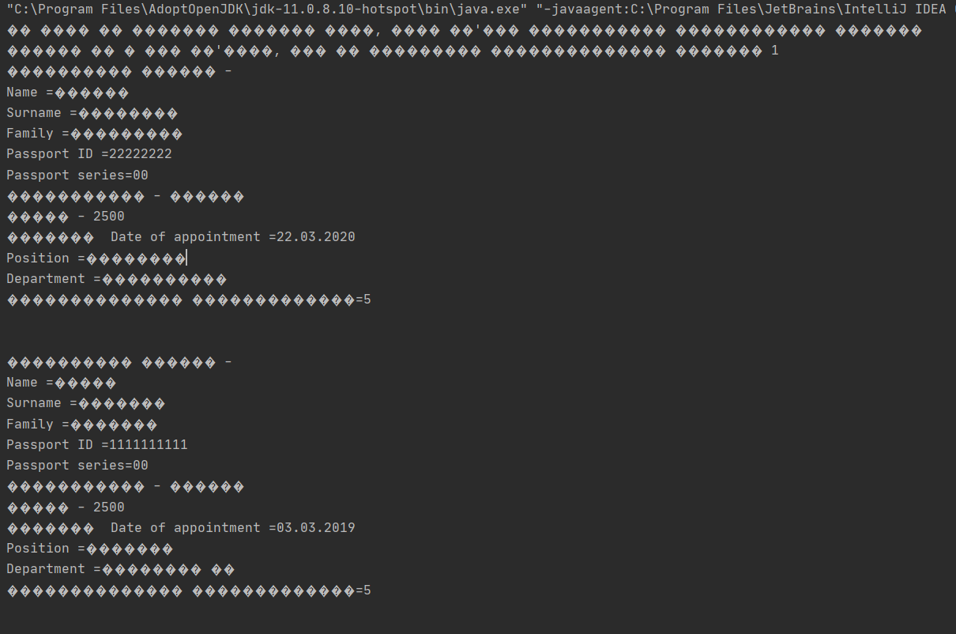
Рисунок 1.1-Режим auto

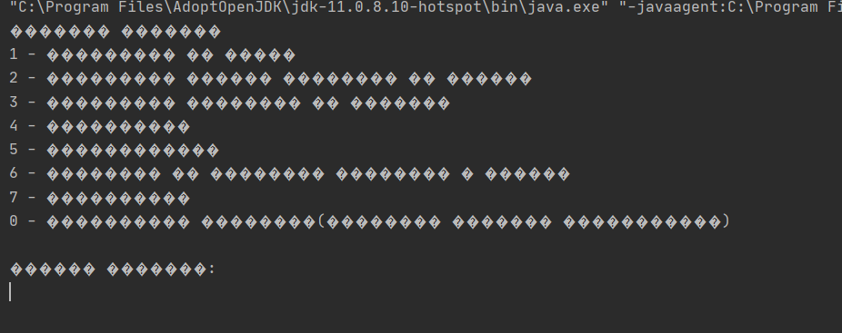
Рисунок 1.2-Режим dialog
Висновок:Виміряв часу паралельних та послідовних обчислень.Демонстрація ефективності паралельної обробки.

